Lab 11

Zoe Boyle

Lab time: 5-5:50

**Part 1**

1. unsafepass



1. SafePaswd0192837465



1. bbqqpp11223344



1. T20s9Q02lwmc2a



**Part 2**

1. radar



1. Gate man sees name, garageman sees name tag



1. Some men interpret fine memos

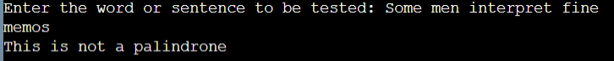

1. Do geese see God?



**Part 3**

